14.77: a) The net inward force is 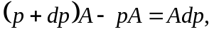 and the mass of the fluid element is 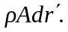 Using Newton’s second law, with the inward radial acceleration of 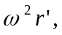 gives 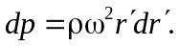 b) Integrating the above expression,

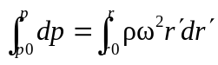

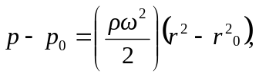
which is the desired result. c) Using the same reasoning as in Section 14.3 (and Problem 14.78), the net force on the object must be the same as that on a fluid element of the same shape. Such a fluid element is accelerating inward with an acceleration of magnitude 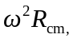 and so the force on the object is 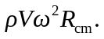 d) If 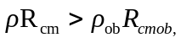 the inward force is greater than that needed to keep the object moving in a circle with radius 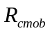at angular frequency , and the object moves inward. If 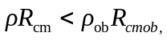, the net force is insufficient to keep the object in the circular motion at that radius, and the object moves outward. e) Objects with lower densities will tend to move toward the center, and objects with higher densities will tend to move away from the center.

